Send a letter to a landmark and Light It Up Red!
Below is an example of a request to a landmark to “Light It Up Red” and raise awareness for World Hemophilia Day. You can modify this example as you wish and send it to local landmarks in your community and country! If you coordinate the lighting up of any buildings or monuments in your city or country, let us know by emailing marcomm@wfh.org so we can spread the news.

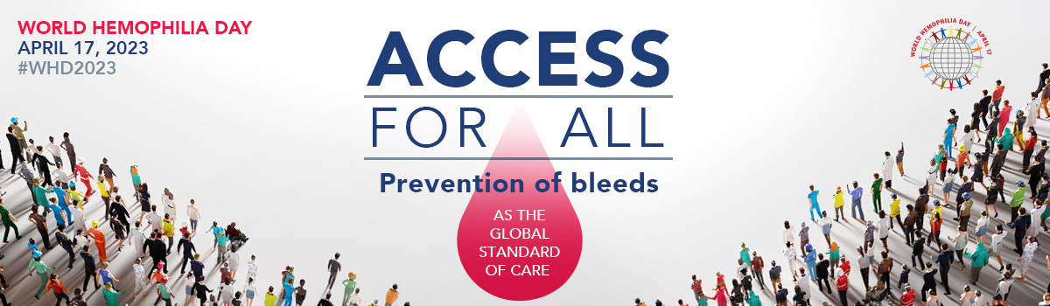

Good afternoon,

On April 17, 2023, the World Federation of Hemophilia (WFH) is asking landmarks all over the world to Light it Up Red! in the name of World Hemophilia Day. Lighting up a building or landmark in red will help bring attention to those affected by inherited bleeding disorders.

The theme of World Hemophilia Day this year is “Access for All: Prevention of bleeds as the global standard of care “. By raising awareness and bringing hemophilia and other inherited bleeding disorders to the attention of policymakers, we can increase sustainable and equitable access to care and treatment.

Light It Up Red is a campaign championed by the WFH, an international not-for-profit organization and global network of patient organizations in 147 countries. The WFH has been providing global leadership to help improve and sustain care for people with inherited bleeding disorders—including hemophilia, von Willebrand disease (VWD), rare factor deficiencies, and inherited platelet disorders—for nearly 60 years.

The international bleeding disorders community has seen amazing participation over the past few years for the Light it Up Red! initiative. In 2022, over 125 major landmarks around the world participated—a record!

For more information regarding World Hemophilia Day please visit wfh.org/whd.

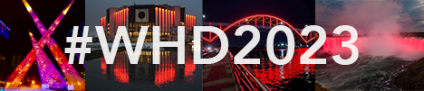
We kindly ask you to post photos of buildings and landmarks that have been lit up red on social media, using the hashtag #WHD2023.

Thank you very much for taking the time to consider our cause, and I look forward to hearing from you!

Best,

